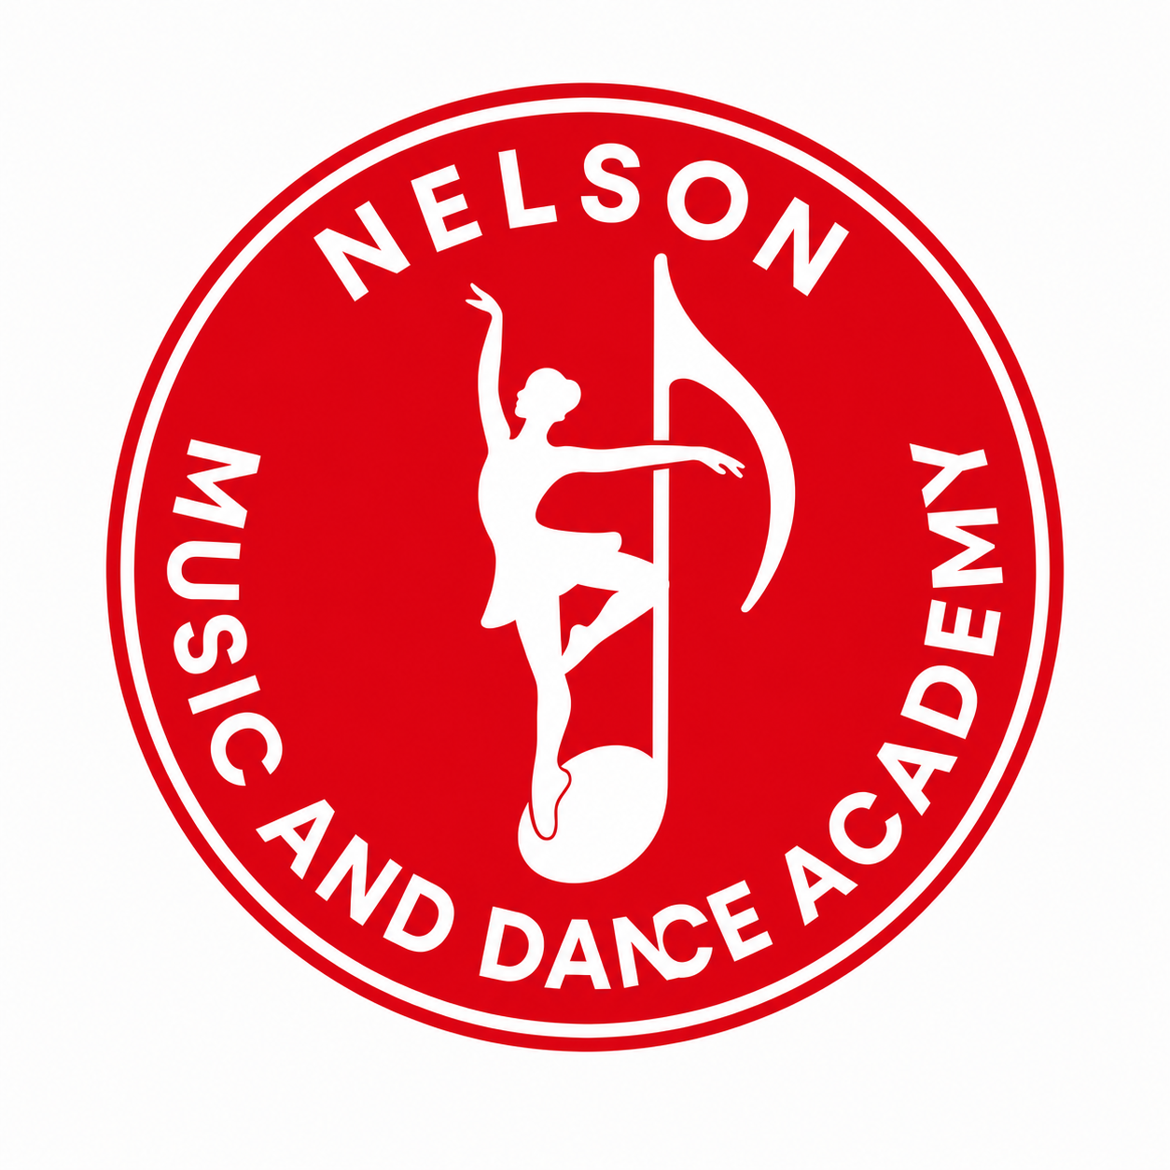
ENROLL NOW
Join Nelson Music and Dance Academy
Discover Your Talent. Develop Your Potential. Inspire Your Future.
At Nelson Music and Dance Academy, we believe every child and young person has unique creative potential. Our programs provide professional training in music, dance, drama, and creative arts within a supportive and inspiring environment.
Whether you are enrolling in our regular classes or our Holiday Creative Arts Workshop, we are excited to welcome you to the NMDA family.
LOCATION  Buea, Cameroon | AGE  5 years and above
ENROLLMENT  Open Throughout the Year | CLASSES  Weekdays and Weekend Sessions Available

WHY CHOOSE NMDA?
[ ] Professional instructors | [ ] Safe and child-friendly learning environment
[ ] Performance opportunities | [ ] International-standard training
[ ] Certificates of Participation | [ ] Individual and group instruction
[ ] Creative confidence and leadership development

Complete the following pages clearly. For applicants under 18, a parent or guardian should complete the parent/guardian and consent sections.

CHOOSE YOUR PROGRAMME
Select one or more programmes of interest.
Music
[ ] Piano | [ ] Keyboard
[ ] Voice Training | [ ] Music Theory
Dance
[ ] Ballet | [ ] Contemporary Dance
[ ] Liturgical Dance | [ ] Afro Dance
[ ] Salsa | [ ] Ballroom Dance
[ ] Latin Dance | [ ] Acrobatic Rock 'N' Roll
[ ] Acro Swing Dance
Performing Arts
[ ] Acting | [ ] Spoken Word
[ ] Photography | [ ] Holiday Creative Arts Workshop

Programme placement and class schedule may depend on age, experience, instructor availability, and Academy assessment.

STUDENT INFORMATION
Student Full Name  ____________________________________________________  Date of Birth ____________________ Age __________  Gender: ( ) Male ( ) Female ( ) Prefer not to say | PASSPORT  PHOTOGRAPH  Attach here

PARENT / GUARDIAN INFORMATION
Full Name | Relationship to Student
Phone Number | WhatsApp Number
Email Address

Home Address

City | Country

EMERGENCY CONTACT
Full Name | Relationship
Telephone Number

MEDICAL INFORMATION
Please provide information relevant to the student's safety and participation.
Does the student have any allergies? [ ] No [ ] Yes
If yes, please explain:
Medical conditions:
Special learning needs:

PREVIOUS EXPERIENCE
Have you previously studied music or dance? [ ] Yes [ ] No
If yes, please specify:

PREFERRED CLASS SCHEDULE
Preferred Day(s)
[ ] Monday | [ ] Tuesday | [ ] Wednesday
[ ] Thursday | [ ] Friday | [ ] Saturday
Preferred Time
[ ] Morning | [ ] Afternoon | [ ] Evening

DOCUMENTS TO SUBMIT
Attach copies where applicable.
[ ] Passport Photograph
[ ] Birth Certificate (optional)
[ ] Parent/Guardian ID (optional)
[ ] Previous Certificate (if applicable)
For online registration, these documents may be uploaded electronically. For printed registration, attach copies to this form.

PAYMENT METHOD
Select your preferred payment option. Payment instructions will be confirmed by the Academy.
( ) MTN Mobile Money | ( ) Orange Money
( ) Bank Transfer | ( ) PayPal (International)
( ) Pay at the Academy

CONSENT
[ ] I certify that the information provided is accurate.
[ ] I agree to the Academy's Terms and Conditions.
[ ] I consent to the use of photographs/videos for educational and promotional purposes.
Parent / Guardian or Adult Student Declaration
Name | Signature
Date

SUBMIT YOUR REGISTRATION
After submitting: You will receive a confirmation email; Academy staff will review your application; and you will be contacted within 2-5 business days.
SUBMIT APPLICATION
Thank you for choosing Nelson Music and Dance Academy.

